## Simple Regression: an overview

-Regression provides a general framework for the estimation and testing procedures that we covered in the first term

**Basic Structure**

A linear equation

F(y) = B0 + B1X1 (X1 is the predictor of interest)

F(y): depends on what **variable type** the outcome of interest (y) is – and, in term, what regression will be used

Continuous: the left-hand side is the mean of the outcome y bar

Binary outcomes: Left hand side is **ln(odds)**of the binary outcome i.e. ln(p/1-p), where p(y) = 1

Time-to-event outcomes:

1)Where the individual and censoring times are not known, y is a yes/no indicator of whether the event occurred in the common follow_up period. LHS = **ln(incidence rate)** – a poisson regression is used

2)individual event and censoring times are known, y composites both time and whether the event occurred. LHS = **ln(hazard rate)**—a cox regression is used

Right hand side:

B0 + B1X1

The predictor of interest can be continuous, binary or categorical ( in which case it will be represented by more than 1 x)

**Binary Predictors**

-X1 is a binary predictor, such as sex (M =1, F = 0)

The resulting regression is F(y) = B0 + B1X1

There are 2 possible values of X1, 0 and 1 which give F(y) = B0 + B1X1  or F(y) = B0

B0= value of LHS when X1 = 0 ( for males)

B1 = difference in value of LHS for X1  (for females compared to males

**Nominal Categories**

E.g. you want to code x when the predictor of interest is a nominal category (e.g. locations, A ,B ,C)

-Designate one of the categories as the **reference**

-We will need an additional variable for each categorical variable (and x = 1 or 0)

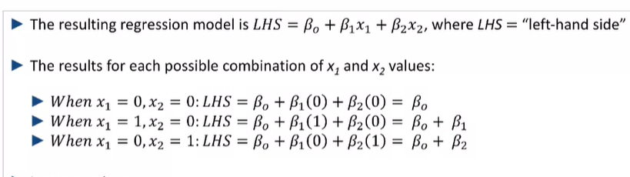

**Shown for 3 categorical variables – there is only 1 variable = 1 at all times (i.e. only data from one location)**

When A: function of X = B0

B: Function of X = B0 + B1

C: X = B0 + B2

**So what’s the difference between this and testing**

-Allows for continuous predictors

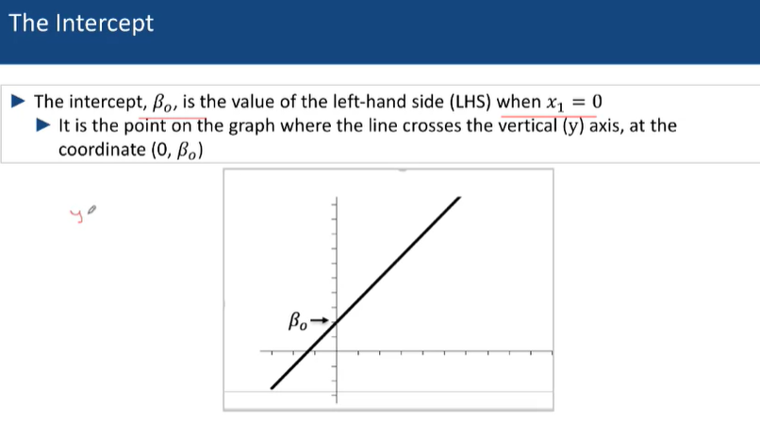

## Simple linear Regression -- Binary (or Nominal Categorical) Predictors

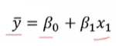

-We will only be able to estimate the regression equation from a sample fo data – thus **Everything used is an estimate** – and we must use the hat versions

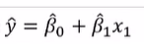

**Example**

---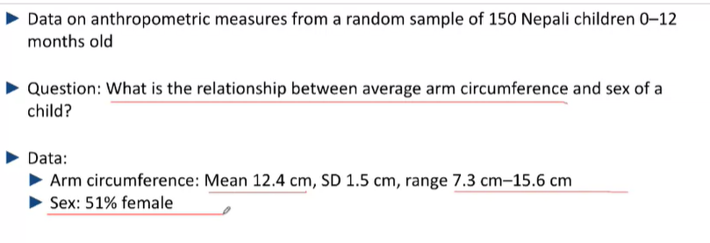

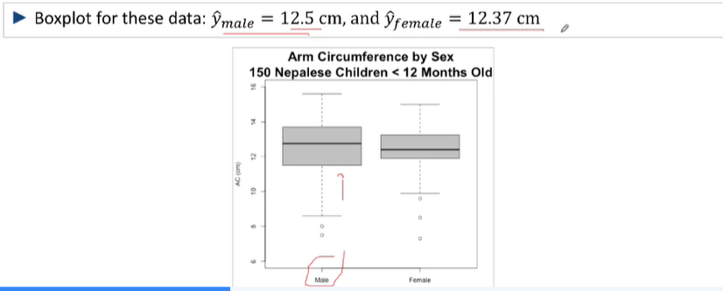

Y – Circumference (continuous)

X1 is not continuous – binary – male or female

Constructing the regression:

X1 = 0 for males and 1 for females

The equation to be estimated is   
 Y^ = B0^ + B1^X1

B0 is the mean value of the variable that is coded to 0 in X1 (if it’s a binary variable) (reference group)

This B1 estimates the mean difference in arm circumference for females compared to males (slope)

-The difference in Y^ for a one-unit difference in X1 (number of females)

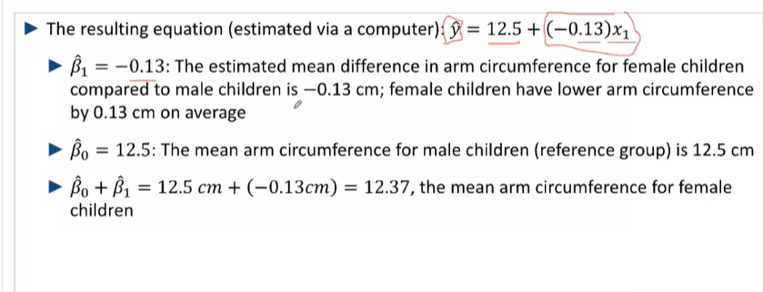



Thus B1  is the estimated mean difference in arm circumference, or any other variable, from the reference for the selected group

And it can be graphed as so (the following straight line):

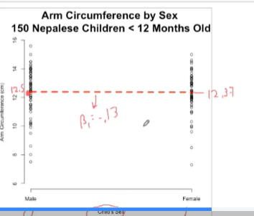

-The regression can be coded with the binary values reversed too

## Simple Linear Regression – (Nominal) Categorical Predictors

**How can predictors model multiple Categorical Predictors**

**Example: examining salaries between US phsyiscians**



Potential Factors modelled:  
 -Geographical Region (n, s, e, w)

Approach:

* Designate one region (factor) as the reference region
* Make **Binary indicators for each of the 3 other regions**
  + X1 = 1 if S, X2 =1 if N …..

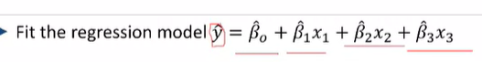

* B1, B2, B3 represent the differences in salary (y) between each of the regions and the reference region
* B0 represents the salary (y) pf the reference region

For Y^ = B^0 + B^1 X1 + B^2 X2 + B^3 X3

For individuals falling into the **reference**, X1,X2,X3 = 0

Thus , Y^ = B^0

For individuals falling into **group A** (let it be the Western region), X1 = 1, X2 & X3 = 0

Y^ = B^0 + B^1

So on and so forth (**for any other group**)

**According to the article**

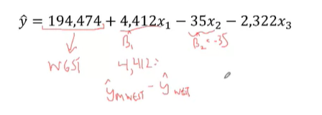

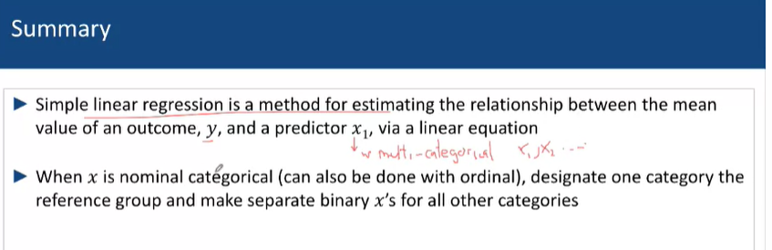

## Simple Linear Regression – Continuous Predictors

Examples: Nepali Children

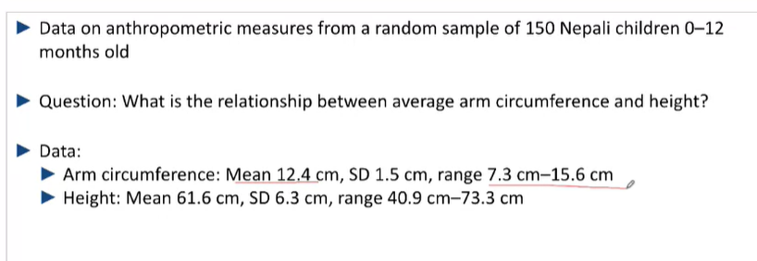

**Predictor – Height:**

-Continuous Height can be dichotomized as above or below the median -- and used as categorical ***(however, perhaps groups can be split to conduct hypothesis testing on them, to identify if there are associations in only certain groups/for certain traits)***

-Categorise height into 4 categories by quartile --- compare mean arm circumference via mean differences across quartiles

But the previous 2 require multiple summary measures (differences between means/medians) and throws away a great deal of data

**OR you could treat height as a continuous carriable when estimating the arm circumference/height r/s**

* But only if the line can reasonably describe the circumference v the arm

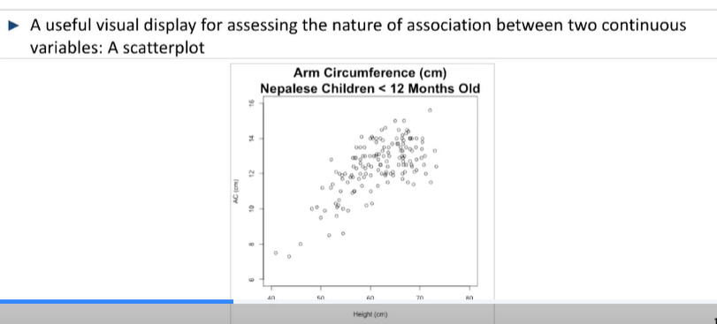

Estimate Y^ = 2.7 + 0.16X1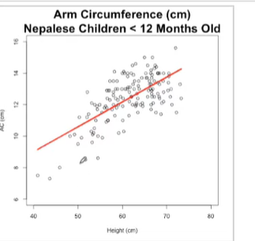

Here

B^1 : average change in arm circumgerence for a 1 unit increase in height = 0.16 (within the range of data that was used to create the regression)

X1 : Per Unit height

B0: useless if it is outside of the range of data – which is often the case – and not scientifically relecvant

Y^: mean circumference of arm with height

**Limitations**

However:  
The range of observed heights = 40.9cm – 73.3cm

And thus, the regression results only apply to the relationship between the variables within the range of data – I.e.  **they cannot predict or model variables out of the range of data used to create them**

**Scatter plots**

-use exploratory LOWESS (For R) – makes a smoother line

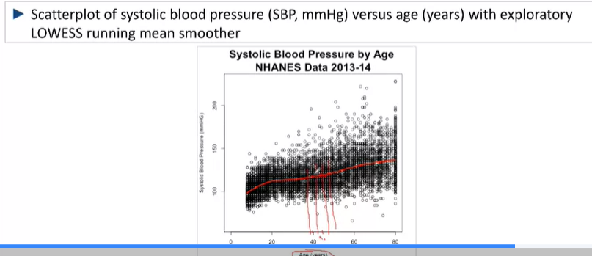

**Summary**

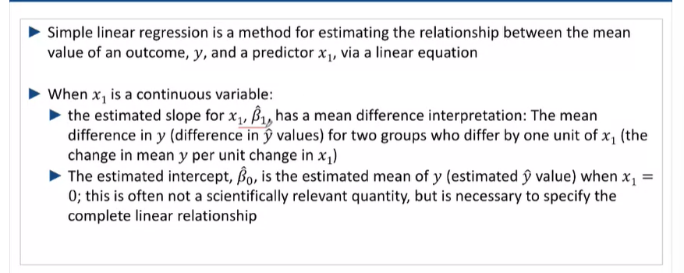

## Simple Linear Regression – Estimating the Regression Equation and accounting for Uncertainty in the estimates

-Algorithim to estimate the equation of the line is called the least squares estimation

-Aggregating the cumulative squared distance between each point’s Y value and the corresponding value on the regression line for the same (X1) I.e measuring the sum of the squared distances between each point and the regression line

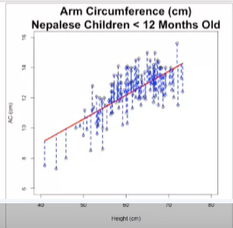

Given Yi  = B0 +B1 X1 ….

Distance = Yi  - Y^ -- residuals from the regression model ( the discrepancies between estimated and observed y-value)

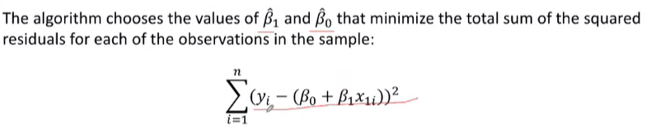

-The method also yields SEs for the slope and intercept estimates B1^ and B0^

-The standard errors allow for the computation of the 95% Cis and P-values for the slope and intercept

-**The variables B1 and B0** are also approximately normally distributed for infinitely many different samples of the same size

-H0: B1 = 0 (our data comes from a population where our true population regression is 0)

-HA: B1 =/= 0

**Example – Arm circumference**

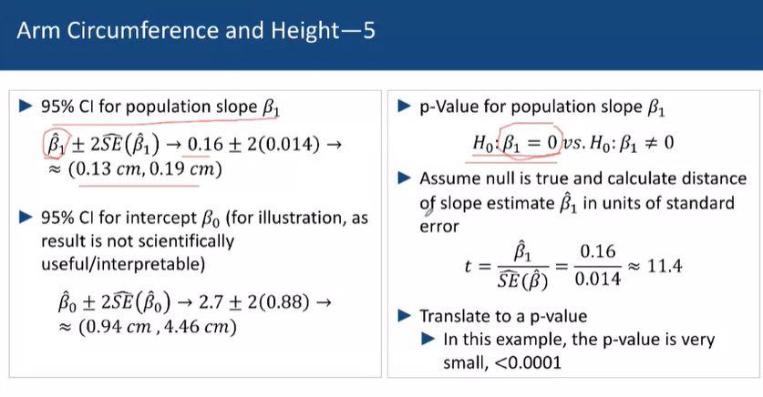

This research used simple linear regression to estimate the magnitude of the association between arm circumference and height in Nepalese children less than 12 months old, using data from a random sample of 150

A statistically significant positive association was found (p<0.001)

The results estimate that the 2 groups of such children who differ by 1 cm in height will differ on average by 0.16cm in arm circumference (95% CI 0.13 cm to 0.19cm)

i.e. there is no association between age and arm circumference

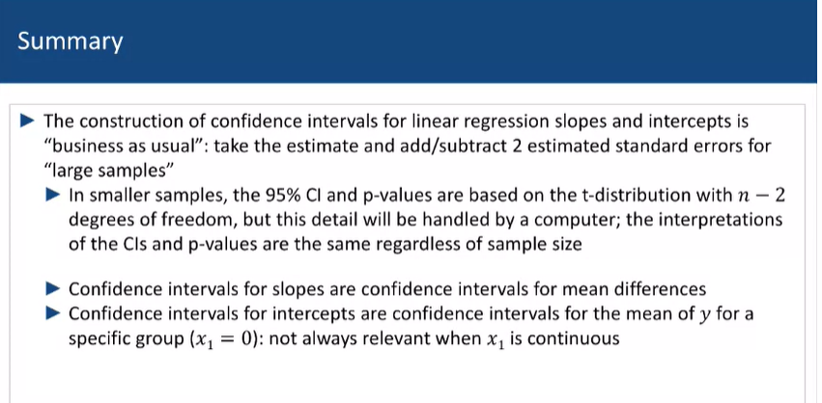



n-2 degrees of freedom because 2 things (intercept and slope) must be estimated with n amounts of data

## Measuring the strength of a Linear Association

* The slope of a regression line estimates the magnitude and direction of the relationship between y and x1
* **However, we cannot determine how well the slope of the regression fits the data**

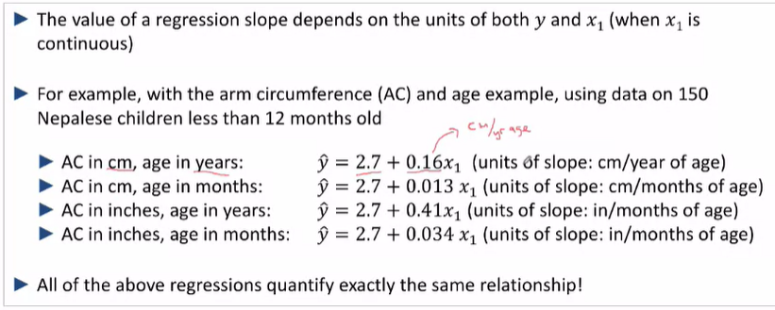

-Thus, while you can scale the slope of the regression differently depending on the units you decide to use, the value and magnitude of the slope cannot quantify the strength of the relationship ( affected by the choice of units for both y and x)

**Coeeficient of determination, R2**

-Measures the strength of association by comparing **(a) variability of points around the regression line** to **(b) variability in y-values** ignoring x1

(a): accounting for height

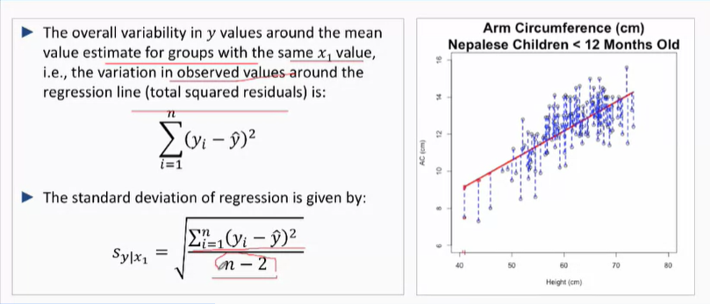

-The ***residual standard error*** quantifies the variability in y **not explained by X1**

(b): Height is not taken into account

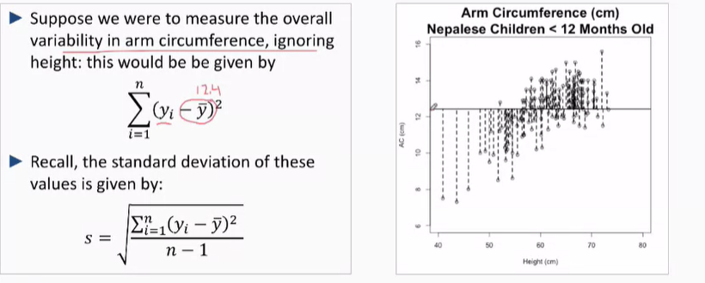

The smaller (a) is compared to (b), the better the fit of the regression

The proportion of the overall variability in Y not explained by X1 (i.e. not explained by the linear regression) is given by: (a)/(b)

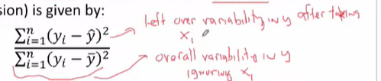

The proportion of variability explained by taking X1 into account (i.e. explained by the linear regression:  
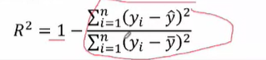

**Strength of Regression**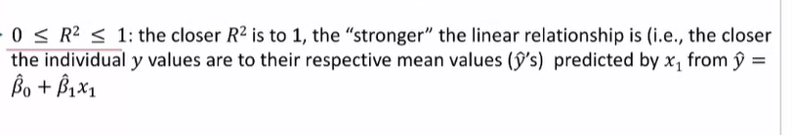

When R2 = 1, the variability is fully explained by the regression model

**Example**

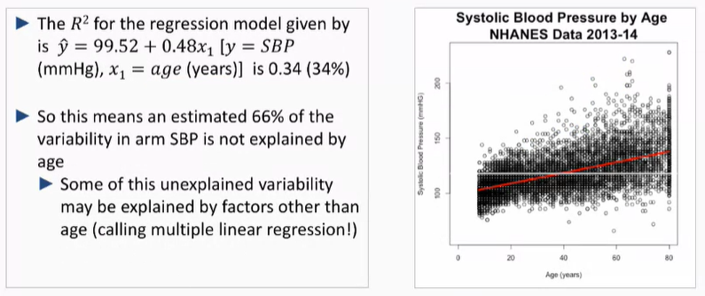

-Flat line is the original grey line of mean

-Red line is the variability

**R2 for Dichotomous variables**

-R2 is typically extremely small for dichotomous variables

-as there may be other variables that explain the variability

**Notes about R2**

-R2 is often not reported with a CI as it’s hard to estimate

-**Low R2 is not necessarily bad: many outcomes will not or cannot be fully explained by one predictor and there are often many different predictors at play**

**-A high R2 value is good though as it means that x1 predicts y for individuals in a sample/population, as individuals y-vlues vary less about their estimated means based on x1**

-Even if r2 is low, there may be important association, for example, systolic blood pressure

-age explained an estimated 34% of the variability in SBP (R2 = 0.34)

-The association was statistically significant (p-value <0,05, no null values in the 95% CI), showing that average SBP is larger for older persons

-However, for any age (year) (x1), there is still substantial variation in the SBPs (y) for individuals

**r , the correlation coefficient**

* Properly signed and also shows the direction of the association
* The value is usually larger than R , given that you are sqrting the R2 value that is less than 1
* Direction, (positive or negative) follows the direction of the association

**Utility of r**

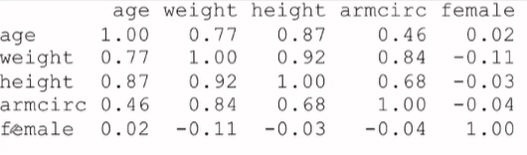

# Logistic Regression

## Simple Logistic Regression – An overview

-Relating Binary outcome to a single predictor (y) that can be categorical, binary or continuous

-Y as a binary outcome – you are modelling the ln(odds that y = 1 (true))

-We model the ln(odds that y =1) = ln(odds of the event – e.g. child getting the disease)

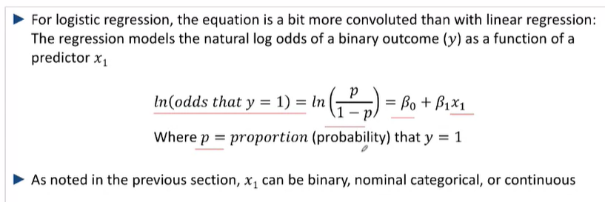

-Any estimated ln(odds) can then be converted to an estimate proportion p^

**Variables**

B0 the estimated ln(odds that y =1) when x1 (our predictor = 0

B1 the change in ln(odds that **y = 1**) for a 1-unit change in x1

What is the difference in ln(odds) then?

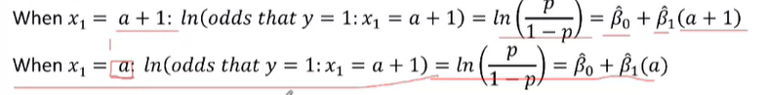

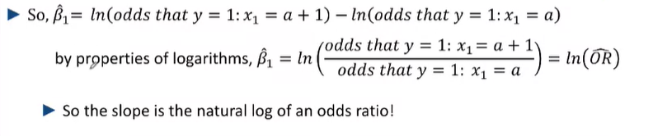

**-B1 is the change in ln(odds^) depending on the presence or absence of the predictors X1,2…**

**-B1  is ALSO ln(OR^) of the predictor and reference**

**-It is, however, not the Ln(change in odds^) between the 2 groups**

As ln(odds) = ln(odds reference) + X*difference in ln(Odds) = ln(odds reference + Odds diffX)

## Logistic Regressions – Binary (or Categorial) Predictors

Example – obesity and Biological Sex

* 100k observtions on individuals aged 0-80 y./o with data of their BMI
* Obesity is defind as having a BMI >=30
* For 5847 adults (>=18yo)

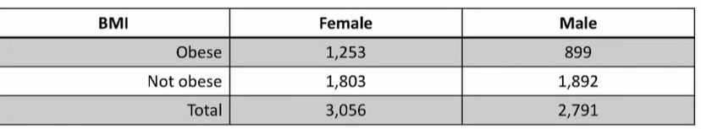

P^Obesity for males and females =889/2791 = 0.41 and 1253/3056 respectively = 0.322

The odds ratio of obesity for females to males 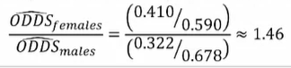

In this sample, females have a 46% greater odds of being obese than males

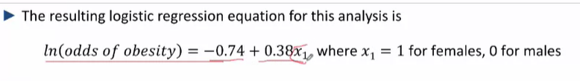

Ln odds for males = -0.74

Ln odds for females = -0.74 + 0.38

So here gender is the binary predictor of obesity

B1 = 0.38 estimates the difference in the ln (odds of obesity) for females to males

B1 = ln(odds for females) – ln (odds for males) = ln(odds for females/odds for males) = ln (OR^) ALSO EQUAL TO THE Difference in Ln (odds^)

Thus OR^= eB1^ = e0.38 = 1.46

B0^ = ln [the odds of the event (obesity) happening in the reference group (males) ]

Odds^ males = eB^0 = e ^-0.74 = 0.45

Example – Response to ART, HIV+ individuals and baseline CD4 Count groups

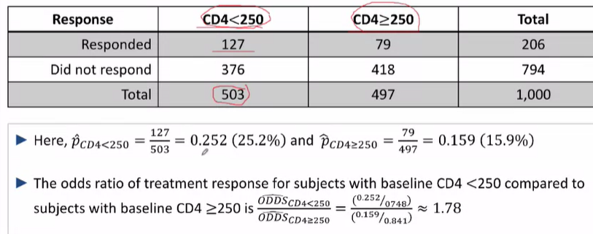

Thus, individuals who had CD4 Counts of lower than < 250 had a 78% greater odds of responding to therapy as compared to individuals with a CD4 count of >=250

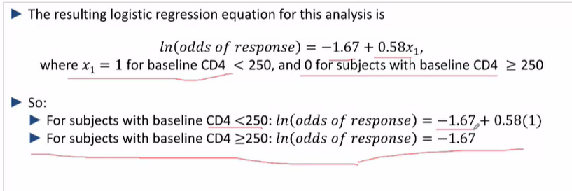

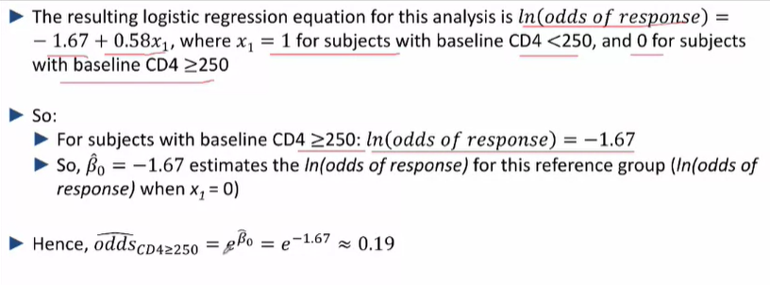

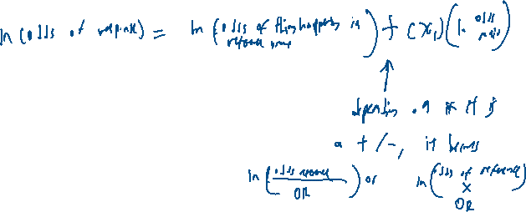

## Logistic Regression – Categorical Variables

E.g. Respiratory Failure and Gestational Age – 1

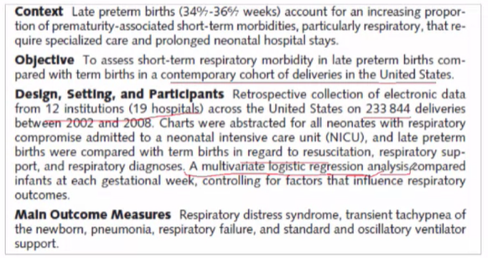

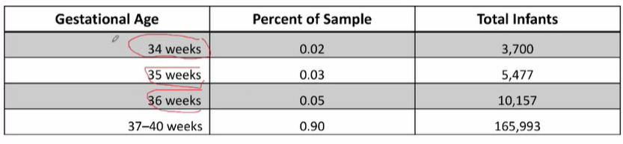

-34 – 36 weeks == preterm baby

-Even though the gestational age ategories are ordinal, we don’t want to assume the r/s between ln(odds of respiratory failure) and gestational age category in linear

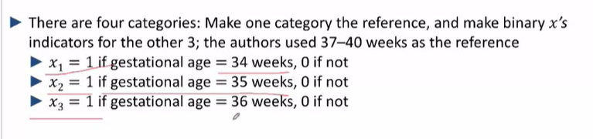

-Each of the gestational ages might have different impacts on respiratory failure

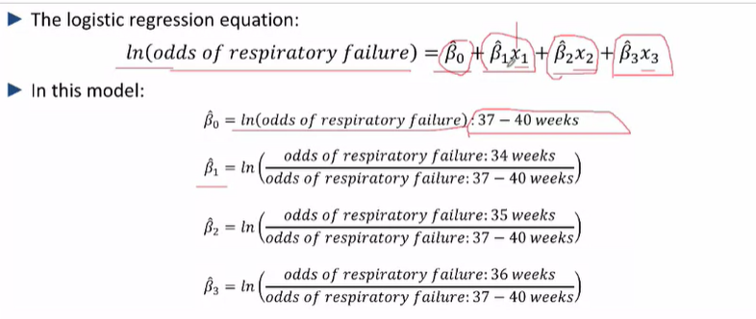

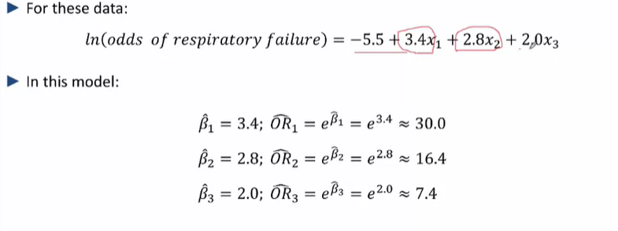

As you can see, the odds ratio of aving respiratory failure as compared to babies who are born at term vary differently for different gestational weeks!

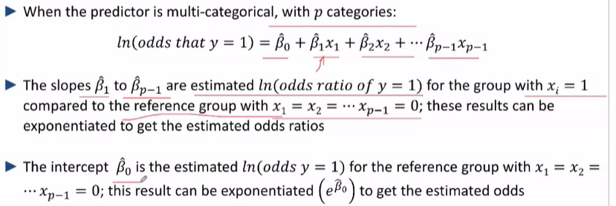

-B^0 is he estimated odds for y (event of interest) happening, when the reference variable of interest is present

## Simple logistic regression with a Continuous Predictor

-When the predictor X1 is continuous, the model **estimates a linear rs between the ln(odds y=1) and x1**

-This assumption **should be investigated empirically (lowess smoothing, categorization of continuous predictors) prior to fitting a moel**

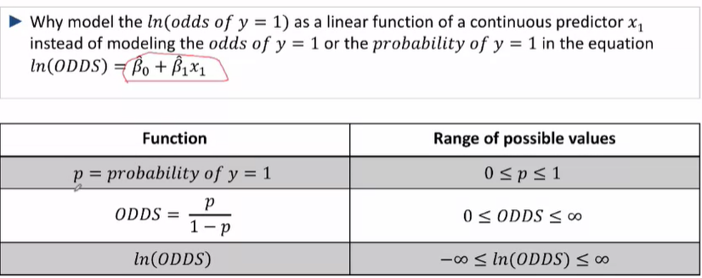

-By ln-ing the odds, the rang of possible values is equalized for odds that are greater and smaller than 1

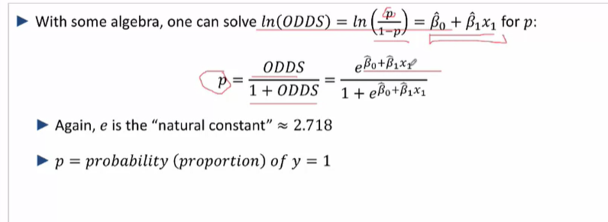

Example, BMI in adults

Ln(odds of obesity) = B^0 + B^1X1

Y = ln (odds of event happening)

B0 = ln(odds of event happening for reference when x = 0)

B1 = ln (OR^) of the event happening for a 1 unit change in X

-For odds ratios, the assumption for H0 is that B^1 = ln(1) = 0, which means OR^= 1

Where

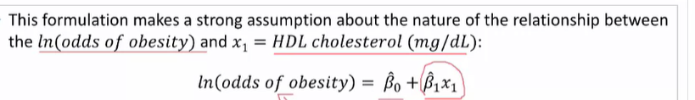

However, this assumes that it is continuous and that the relationship must be linear for all values of the predictor

**Lowess smotthing plots – used for logistic regression for continuous variables**

-estimates log odds for windows of data around X1 – weighted such that data closer to X1 holds more weight

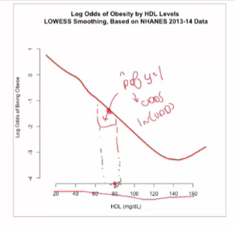

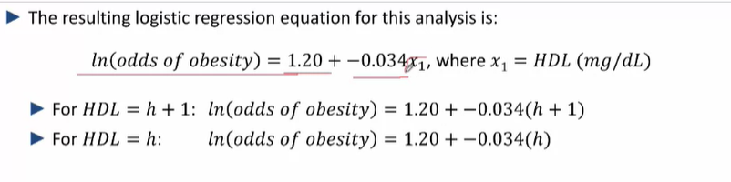

So as HDL (X1) increases, the odds of obesity decreases by 3% for each mg/dl increase in HDL

-The intercept might have no scientific significance

**Comparing the odds ratio of being obese for HDL = 80 and 100**

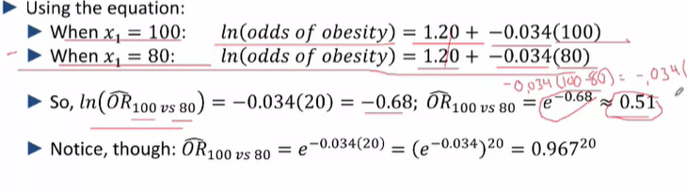The odds ratio here doesn’t describe the absolute difference between the 2 groups

**Example breastfeeding and age**

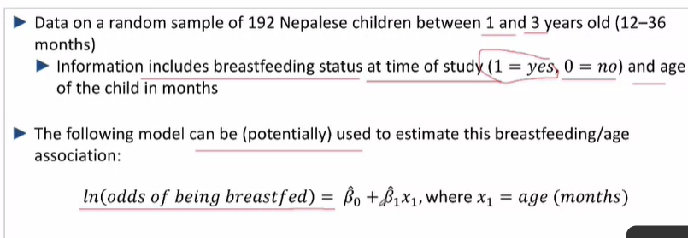

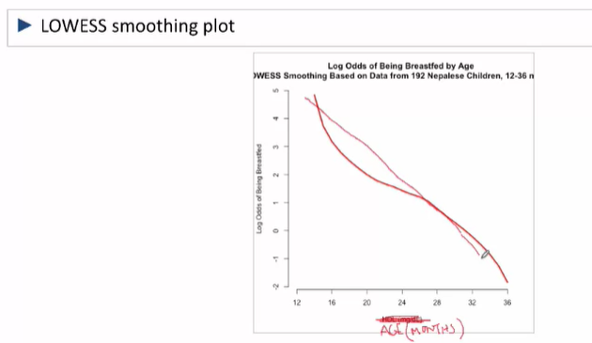

Ln(odds of breastfeeding) = B^0 + B^1X1

Y = ln (odds of breastfeeding)

B0 = ln(odds of breastfeeding at 0 months)

B1 = ln (OR^) of the event happening for every 1 months increase in age (a compounding value per X)

* I.e. for X = n, ln(odds^) = ln(odds reference^) + ln(OR^N)🡪 odds = odds reference^ * OR^N

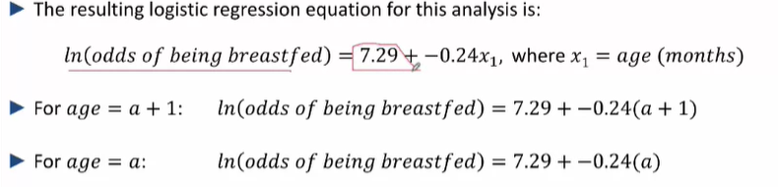

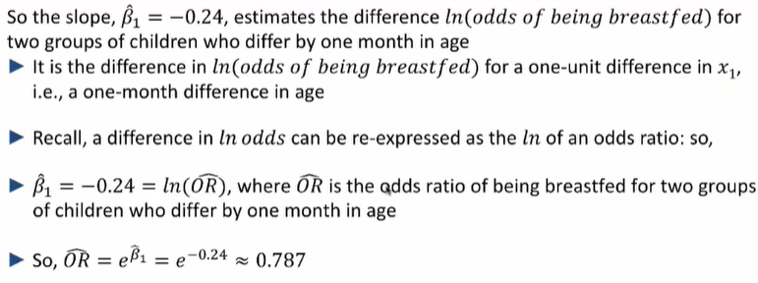

## Simple Logistic Regression – continuous predictors with nonlinear r/s

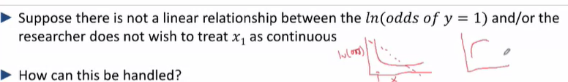

* Categorize the continuous predictors into ordinal categories and treat them as nominal categorical variables

## Simple logistic Regression: accounting for uncertainty int the estimates: CIs, Hypothesis testing

**Binary**

Example HIV

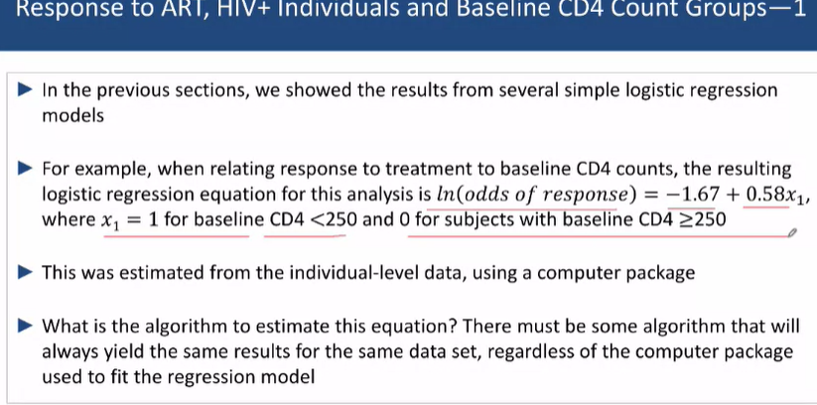

How is a logistic regression developed?

* The computer uses the maximum likelihood methods, iterating through B^0 and B^1 that makes the observed data “most likely” for our **given sample**

-B^0 and B^1 are approximately normally distributed

-95% Cis and SEs can be calculated

-The computer will handle the calculations for smaller samples

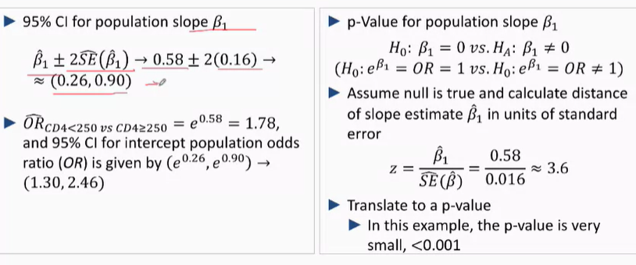

-ln (OR^) does not include 0 which means that OR^=/= 1 (null value) and the result is statistically significant

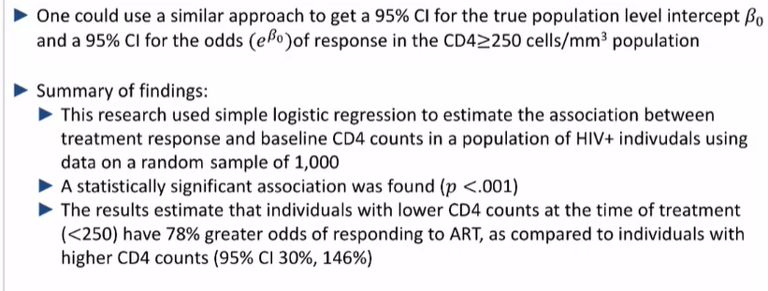

**Continuous predictor**

-Obesity and HDL cholesterol

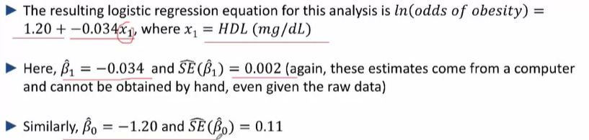

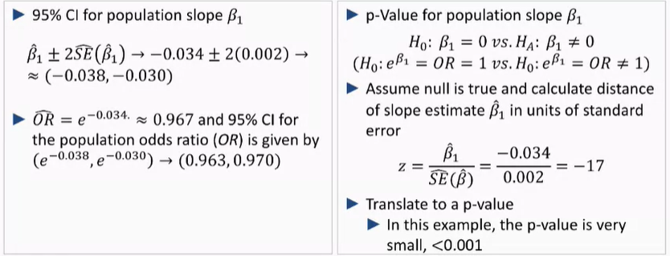

So according to the 95% CI, the OR ranges from (0.963, 0.970)

* A statistically significant association was found (p <.001) and the results estimate that each additional unit increase mg/dl HDL would result in a 3.3% risk reduction in the odds of obesity

## Simple Logistic Regression – estimating risk, probabilities and proportions

-Odds^ = (P^/1-P^) – (1)

P^ = Odds^ / 1+Odds^ -- (2)

Ln(Odds^) = Ln(Odds reference^ ) + X1ln(odds ratio^) – (3)

(3) 🡪 (1) 🡪 (2)

\*\***Logsitic regression of log odds can be used to estimate the proportion and probability which is a metric better suited for proportion**

Example gestational age and respiratory failure

* 4 different groupigns as the authors didn’t want to assume that the r/s between ln(odds) and gestational age was linear

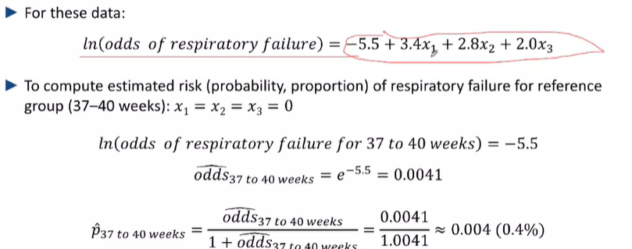

Thus, the proportion of babies who are born at term (37-40) who experience respiratory failure is 0.4%

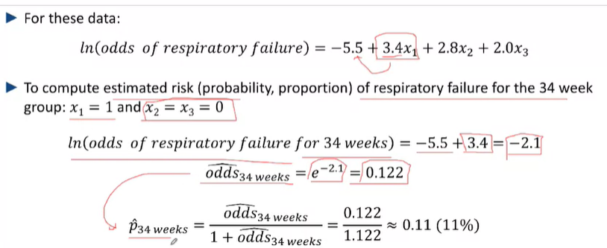

However, the proportion of babies who are born before term, at 34 weeks, who experience respiratory failure is 11% -- much higher than the reference group.

Thus, individuals who are born at 34 weeks of gestation are at, 11/0.4 = some big number *100% , greater risk of experiencing respiratory failure than individuals who are born at term.

**Presenting Results**

* LOWESS Smooth curve
* Relative Risks – graphed

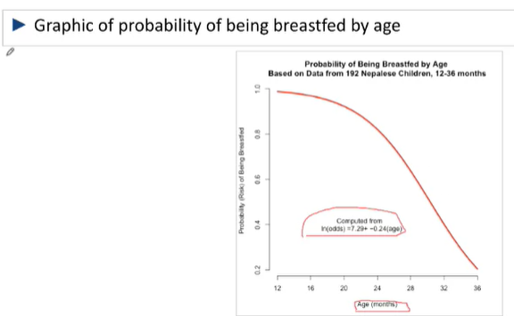

* And compare the ln(odds) scale against the actual scale – to determine if your logistical regression relationship is indeed linear

# Cox regressions – for time to event censored data (to estimate data over an entire follow-up period)

## Simple Cox Regression: An Overview – for time to event data

-The intercept here is no longer static but rather depends on time

-A method for relating a time to an event outcome to a single predictor (binary, categorical or continuous)

-New equation

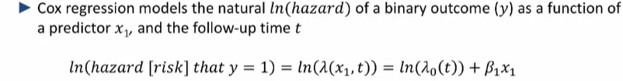

* The intercept varies with time

So what does y=1 mean

e.g. the risk of relapse

y= 1 if a cancer patient in remission relapses, then ln(hazard that y = 1) = ln(hazard of relapsing)

y=1 if xxxx event happens, 0 if not (**or if they get censored**), thus ln(hazard that y = 1) = ln(hazard of event happening)

Lambda, λ, Hazard: instantaneous risk of having the event at a given point of time in the follow up period

-*th time specific incidence*

We can only estimate the regression equation, use hats ^

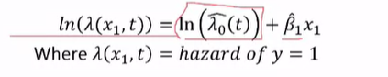

-For a given value of x1 and a **Specific follow-up time t**, the cox regression can be used to estimate the ln(hazard) for a group of subjects with the same value of x1

B^1 Is constant and not dependent on time – assumes that the hazard stays approximately constant

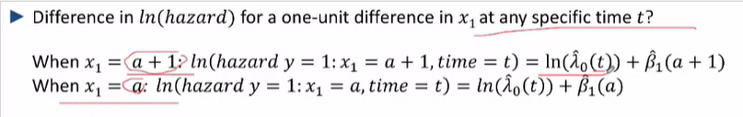



***Thus, Bˆ1 is the natural log of an ESTIMATED HAZARD RATIO (INCIDENCE RATE RATIO)for 2 groups that differ by 1 unit* – that or stays constant with time**

SO what is our intercept?

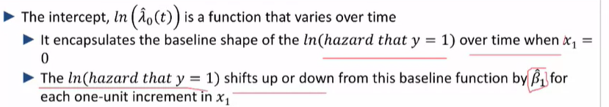

* Ln(lambda) is the baseline function of the risk values depending on how time varies –





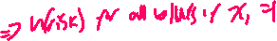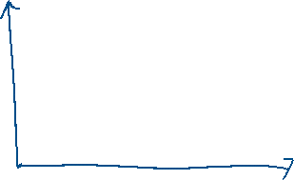

Allwos for the estimation of a ln(hazard ratio) and HR comparing the risk of the outcome over te follow up period between whom x1 differs by a unit

## Simple Cox Regression with a Binary (or Categorical) Predictor

Example – Mayo clinic Study on Cirrhosis – Tracking Death with time for patients who received DPCA and a placebo

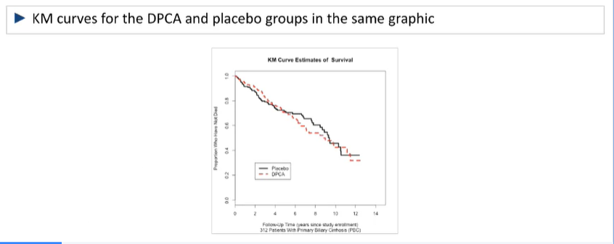

-Very little visual evidence to indicate the 2 groups have different survival trajectories

-Here the binary outcome is if the patient was on a placebo or DPCA

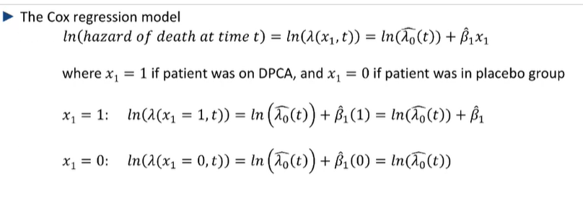

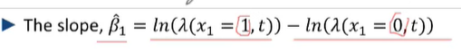

Thus, the **Hazard Ratio** = e^ln(B^1)

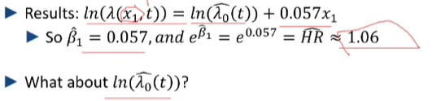

-So, at any point in time, there is a 6% increase in the risk of having the event xxx happening for every unit increase in x1

**Categorical Variables – for 3 nominal groups**

Designate one group as the reference group

Example, risk of infant death for those given the beta carotene, vitamin A and placebo

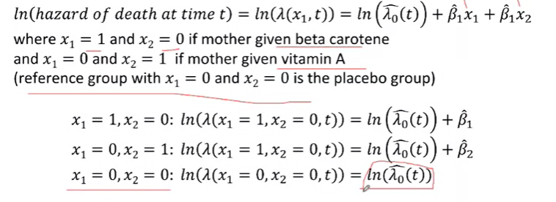

-B^1 is the ln(HR^) of those in the Beta Carotene group to those in the placebo group at any time

-B^2 is the ln(HR^) of those in the Vit A group to those in the placebo group at any time

-However, ln(Lambda) is still the ln(risk) of death (the event happening) for the placebo (reference group) – tracks the natural log of the baseline hazard in the reference groups ( x = 0) with time

## Simple Cox Regressions – continuous predictors

**-we have to ascertain if the relationship between the 2 variables is actually linear because for continuous variables, we are assuming that the increase ,B1^ holds for all values of X1 – which may not be true**

Example – mayo clinic Cirrhosis drug trial

* Patients were followed from enrollment until death or censoring
* The follow-up period was 12 years

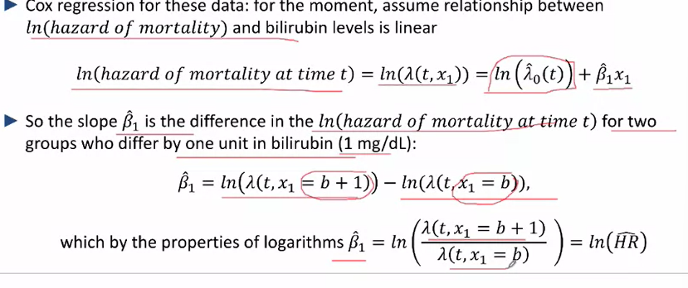

-Assuming that the slope B1^ is 0.15, the estimated HR of death with bilirubin levels that differ by 1 mg/L is e^0.15 = 1.1.6

** Each unit increase in bilirubin levels by 1mg/L results in a 16% increase in the risk of death over the 12 years of follow-up

-The intercept here ln( Lambda^0 (t)) is a baseline quantity 🡪 it establishes the natural log for bilirubin levels = 0 **which in practice will not happen**

**Calculating differences in risk for 2 groups that differ by a non 1 unit of X1**

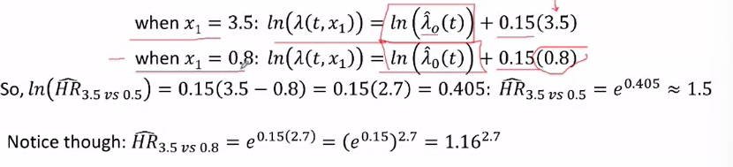

-The Hazard ratio between any 2 groups is equal to the hazard ratio between 2 groups who differ by one unit, raised to the power of the number of units they differ by

**How to assess whether the assumption of linearity in constructing a cox regression for continuous variables is reasonable**

-There is no easy visual tool to help with the assessment

-The linear relationship may only apply for a certain proportion of the data

-An empirical approach can be employed to categorize the continuous predictor into groups (arbitrarily) and see if the difference in ln(hazard) between consecutive ordinal groups is similar:

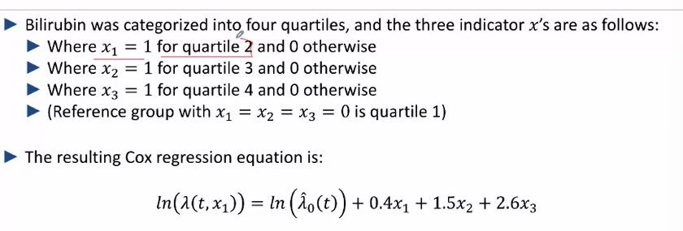

* Where quartile 1 has x= 0, quartile 2,3 and 4 represents the risks (of mortality) associated with the bilirubin data from our current data set
* For a linear relationship, the deltas between the 3 quartiles should be equal but they aren’t, they are 0.4, 0.9 and 0.9
* We can estimate this as a linear relationship though you may overestimate the risks at the beginning

**Kaplan Myer Curves by baseline bilirubin quartiles – deaths**

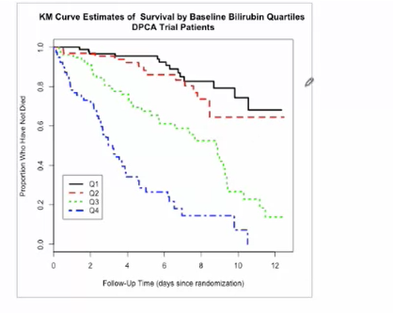

* As you can see the risks of mortality differ with their risks of death

## Simple Cox Regressions – accounting for uncertainty, 95% CIs

* -How does one estimate the parameters? (slope and intercept)
* Partial maximum likelihood – the slope(B^1) is/are the values that make the **Observed**  data most likely for all possible choices of B^1
* The slope is estimated after the baseline hazard function Ln(lambda) is estimated via another process
* Both these processes give rise to uncertainty

Example – Mayo clinc primary bilirubin Cirrhosis drug trial

* For a different random sample of 309 subjects from the same population, we would get a different B^1
* The random sampling behaviour of regression slopes is approx. normal because ln(hazard ratios) are estimates in “large samples”
* -Hence 95% CIs for the hazard (risk) can be calculated albeit on the ln scale

2 approaches:

* Start with our estimated mean +- 2 SE^(ln(lambda^0 ))
* Assume H0 which states that B1  = 0, then measure how far our estimated value of B^! is from the null
* Null value for B^0 = 0, ln(HR^) = 0, HR^ = 1 (ratio = 1, it is a statistically insignificant value)

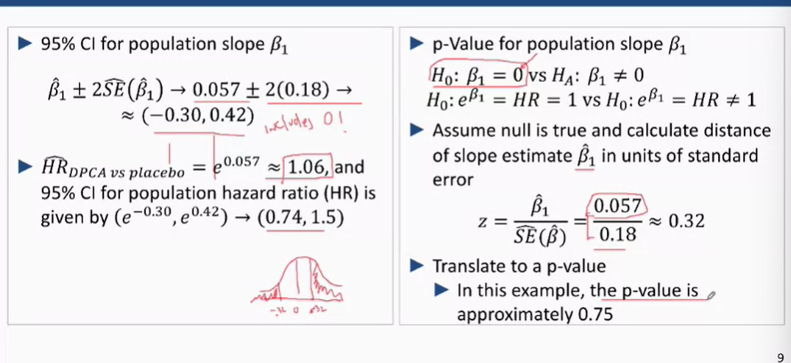

**Stating Results**

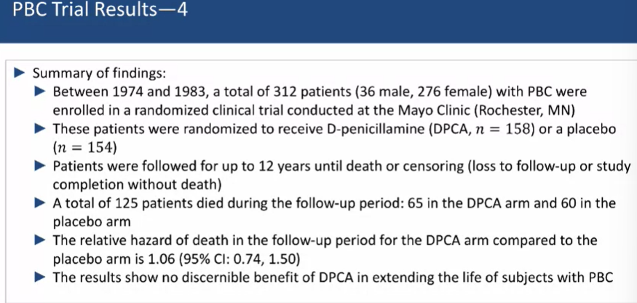

## Estimating Survival Curves from Cox Regression Results

-survival curves, S^(t), can be plotted for different values of X

-Further, when X1 is continuous, the set of survival curves can also be estimated but it’s not possible to display them all – several values of X1 can be specified

How to estimate cumulative survival for a given value of (x1) i.e. S^(t, x1)

1. We must do this by calculating the instantaneous ln (hazard), for each given time – for the given value of X1
2. Then, integrate the function of hazard, from t = 0 to t = t, to estimate the cumulative hazard up to time t
3. Translate the cumulative hazard estimate into an estimate point on the survival curve

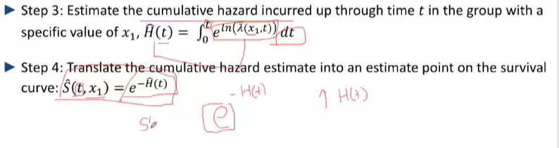

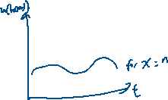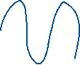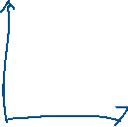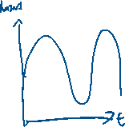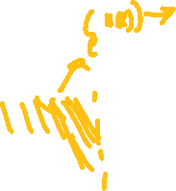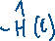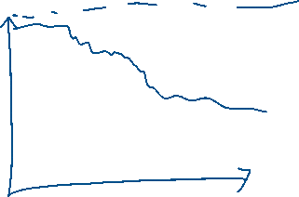

Example, gestational age:

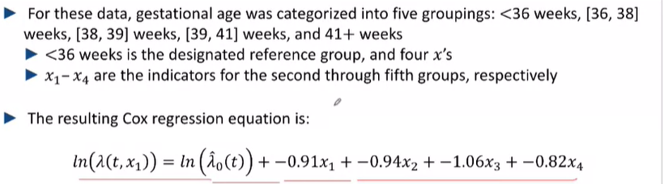

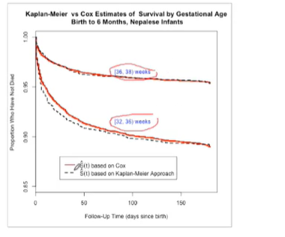

The cox regressions estimate their curves with the same slope, B^1

However, the KM curves are independent of each other

-Taking inti account the 95% CIs of the slopes, B^1 , we can also plot 95% CIs for estimated curves

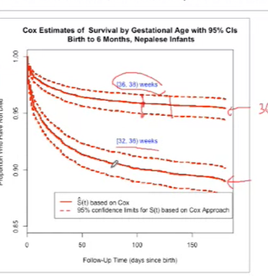

* Statistically significant as the confidence intervals don’t overlap

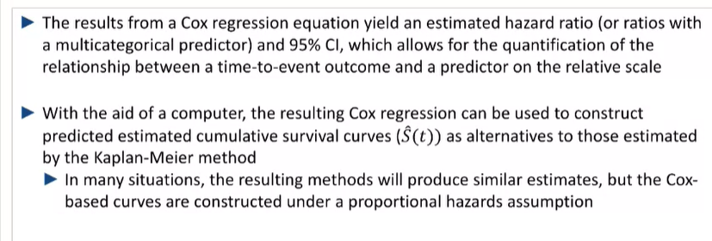

# Confounding and Effect Modification

## Defining Confounding

Simpsons Paradox – the nature of an association can change (and even reverse or disappear_ when data from several groups are combined to form a single group

A confounder Z – distorts the true relation between X and Y

This can happen if a confounder is **related to both X and Y**

To examine the relationship independent of Z, hold Z constant while investigating X and Y

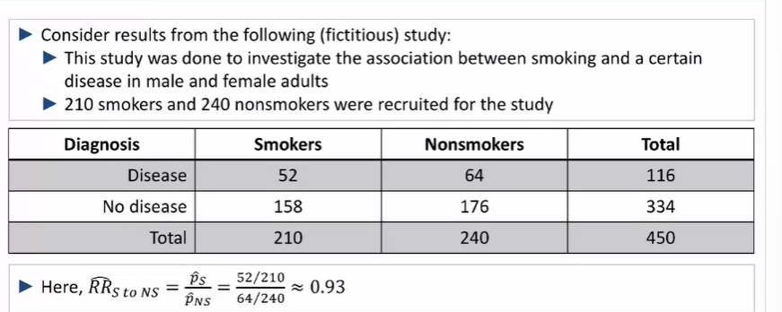

Additional Variable

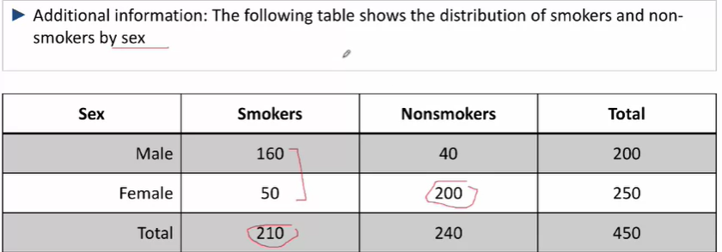

Males are much more likely than females to be smokers

* A breakdown of male and females who have disease

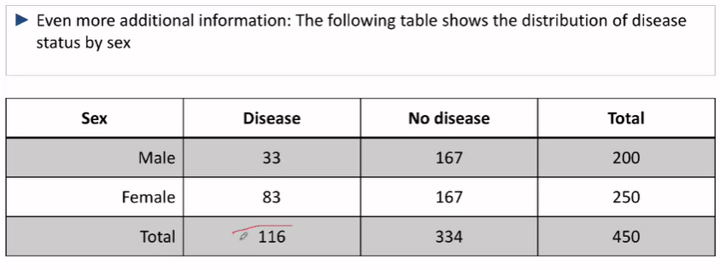

-it seems that the females have a greater risk of disease than males

-Thus, it would seem that the variable sex is affecting the variable of interest (how many people in the smoking and non-smoking groups get the disease as the distribution of genders is not the same between them)

**-To solve this we can break this down by sex, seeing how many smokers v non smokers contract the disease in males only and females only**

-Then, the relative risk of disease for smokers to non-smokers are 1.8 and 1.5 for males and females respectively

Sex

Smoking

Disease

## Batch Effects – Lab-based results can be influenced by the technician, lab used, time of day etc.

* It cannot be ascertained if differences in lab measures between the 2 groups (Diseases and non-diseased), and the group is due to actual differences in the groups or due to differences in experiment setup

## Adjusted Estimates: Presentation, Interpretation, and utility for assessing confounding

Adjustment is a method for making comparable comparisons between groups in the presence of confounder(s)

-Contrasting the magnitude of crude and adjusted association estimates is useful for identifying confoundign

* Relative risk comparing all smokers to all nonsmokers without taking any other factors into account is called the *unadjusted or crude estimated association*

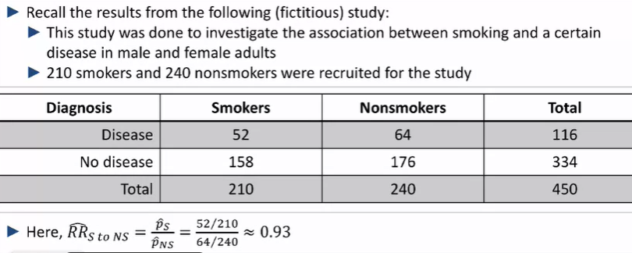

* Here, the R/s can be adjusted for Sex

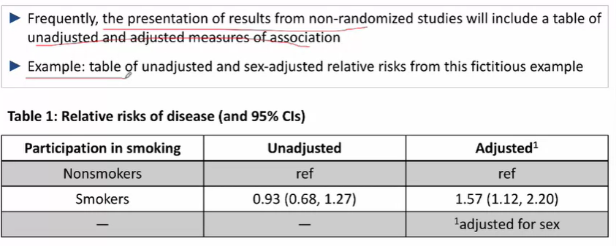

* The important part is to compare both the unadjusted and adjusted relative risks of disease (and their 95% CIs)

-Unadjusted, compares the risk of disease regardless of any other characteristic, and estimates the comparison of all smokers to all non smokers in the population sampled

-Adjusted compares the risk of disease for smokers to non smokers of the same sex in the sample and hence the risk of disease for male (smokers and nonsmokers) and female (smokers and nonsmokers) respectively

* Examine the above data both qualitatively and quantitatively, there is some overlap in the 95% CIs of the adjusted and non-adjusted relative risks which indivates a possibility of statistical insignificance
* However, given the large change (from 0.93 which indicated no association ,to 1.57) we can assume that it is statistically significant

**Example –- Regression Slope**

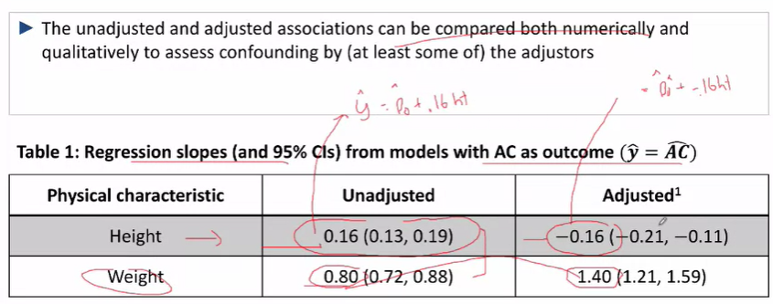

-Unadjusted: the average diff in arm circumference (Cm) between 2 roups of children who differ by 1 cm in height  
-Adjusted: the average diff in arm circumference (Cm) between 2 groups of children who differ by 1 cm **given that they are the same weight**

## The computation of adjusted estimates – the underlying concept

1. Stratify when the Confounder Z is **Categorical**
   * Compute the association between the outcome and the exposure separately for each level (stratum) of Z
   * Take weighted average of stratum-specific estimates
   * E.g. To determine the relative risk of getting a disease for smokers and non-smokers, where males (n = 200) have a RR^ of 1.8 and females (n =250) have a RR of 1.5, we take a weighted average, and so

The RR^to Non-smokers, Adjusted for Sex = 200 * 1.8 + 250 * 1.5 / (450) = 1.6 (weighted avg)

* There are better ways to do this such as: firstly, computing on the ln scale and then weight by SE^
* Multiple Regression will be useful for performing adjustments (logistic regression)

Adjusting e.g. arm circumference

* Generate 2 regression lines, one adjusted and the other not-adjusted for weight. Then, compare their slopes

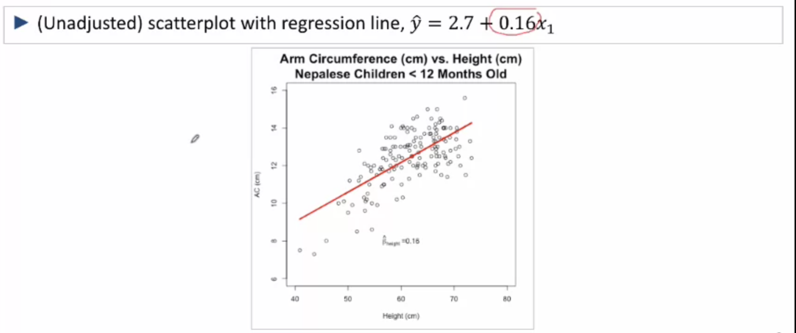

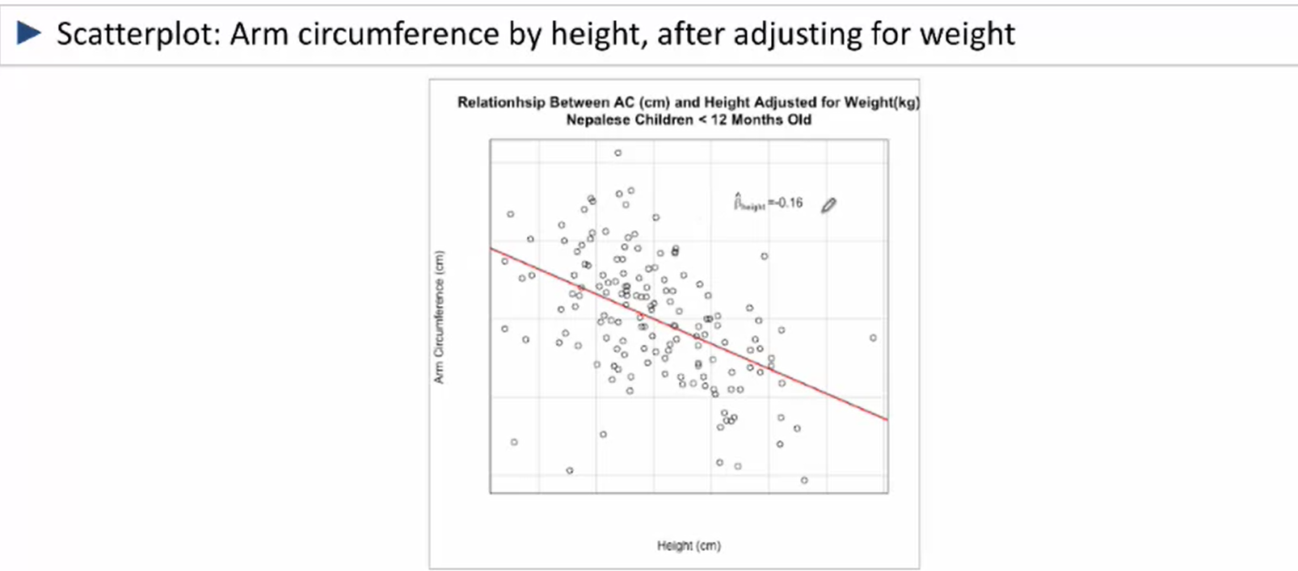

-Adjusting for continuous measures (weight in this case):

Splits the data into individual weight groups

Then in each specific weight strata, a simple linear regression fits the AC/Height data for each stratum

Then, the overall height-adjusted association between arm circumference (AC) and height is a weighted average of the AC/height slopes for each of the individual weight strata

**Summary**

The adjusted association between X and Y, adjusted for a single potential confounder Z, can be estimated by :  
 Stratifying Z

Estimate the Y/X rs for each stratum of Z

Take a weighted Estimate for all XY associations

## Effect Modification

**The effects of a certain variable can differ by group (inherent characteristic) so it’s important to account for this too**

-How it’s different from Confounding

**Confounding** (simpson’s Paradox) the nature of an association can differ substantially in magnitude and direction for unadjusted and adjusted comparisons

X 🡪 Y

**Effect Modification** – The nature of an association can differ (sometimes substantially) across different subpopulations from an overall population

-An association nbetween X and Y can depend on another of variable Z though this effect may not go away even through adjusting 🡪 look at the values of XY for each value of Z

-The relationship between X and Y depends on the third Variable of Z – Z is only related to the relationship and not necessarily X and/or Y

**-Looking at separate Y/X relationships for different values of Z better describe the phenomenon under study**

X **🡪** Y

Example: surgery works much better than drug therapy in younger patients; surgery is notably worse than drug therapy for older patients

* In this case we wouldn’t want to combine these 2 groups for the association between drug therapy and surgery
* Not necesairly a problem

**Assessing effect modification:**

* In order to assess whether there is effect modification, we look at Y/X associations separately for each level of Z, through **stratified analyses or regression**

**Characteristics of effect modification:**

it is not a function not a function of study design per se and thus  **cannot be controlled by study design**

* However, you can design the study to be able to estimate these differences if you identify the potential for effect modification at the point of the study design

**Relationship between confounding and effect modification**

* Neither are necessary for the other to occur
* They can both occur at the same time though
* **Effect modification usually trumps confounding when they occur together**

**Example – primary biliary cirrhosis (PBC) drug trial -- randomized**

* Research question: is there a risk of death based on the drug administered
* Potential for confounding and effect modification by patient sex
* Randomized study

Overall Analysis:

RR^ for Dpca against placebo = 1.06 (0.80 – 1.40) – **unadjusted**

Could this Death/treatment association be confounded by sex?

* In this case, sex would need to be related to both DPCA uptake and risk of death to PBC
* Possible relationships:
  + Males and females could experience different risks of deaths due to PBC (cannot be changed)
  + Males and females could be treated in different proportions by DPCA (e.g. just like how men and women might experience differences in the proportion of each who smoke) 🡪 **randomization of this trial ensures that both sexes choose DPCA equally 🡪 removes confounding due to sex**

Sex

Sex

Death

DPCA

DPCA

Death

The above diagram reflects how we remove the effect of sex on treatment

* The male and female composition for the uptake of DPCA and placebos should be approximately the same

E.g. Placebo: M M F F F F F F F F

DPCA: F F F F F F F F F M

Adjusted Analysis:

The sex adjusted incidence rate raiof of the patients on DPCA compared to patients on placebo was 1.05 (0.81 –1.37) 🡪 same as the unadjusted, showing that adjusting for sex makes it no-different and that randomization has prevented confounding

**Effect modiiation**

Could the treatment affect mortality for men and women differently? (comparing mortality for placebo v DPCA among individuals of the same sex)

* IRRdeath^ females 1.00 (0.73,1.35)
* IRRDeath^ male 1.25 (0.71, 2.20)

While the estimated Relative risks of mortality for DPCA compared to placebo differed numerically for men and women, the 95% CIs for males and females overlap significantly. Thus, there is no statistically significant difference in mortality for men and women and we can conclude that there is no effect modification of the mortality/treatment association by sex

**Effect Modification: Treand elevation Example**

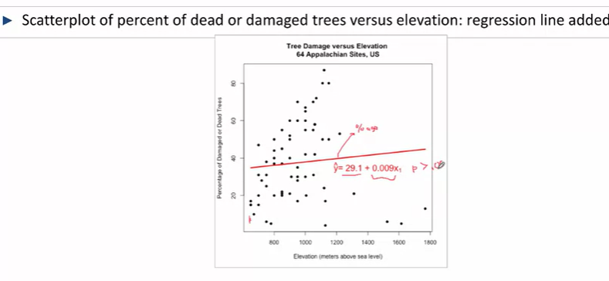

-With all the trees, the result isn’t statistically significant

-However, we can separate them by region (southern v northern)

**Overall Adjusted for region**

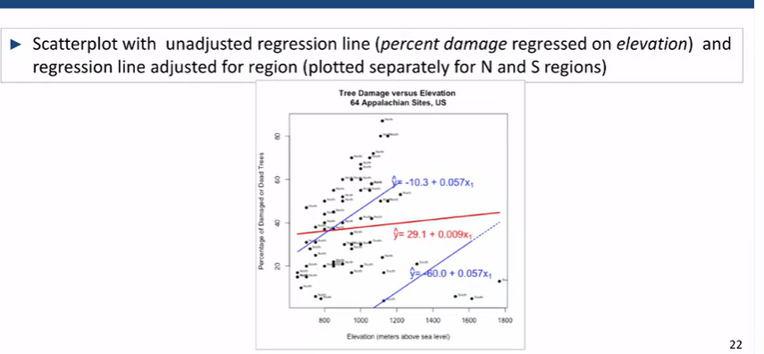

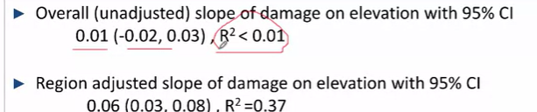

-The (unadjusted slope) is not statistically significant while the adjusted slope is statistically significant

-Adjusted slope gives the percentage difference in damage for one unit difference in elevation when regions are separated and calculated

**Individual between 2 regions**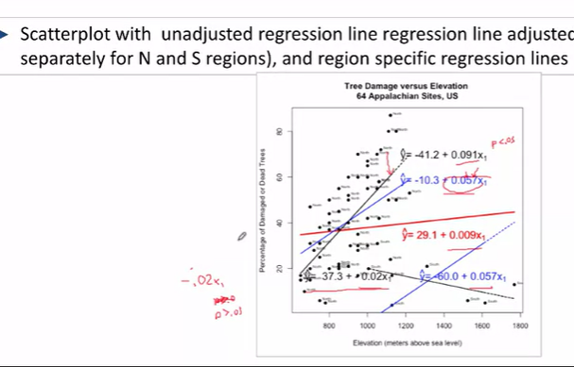

-Effect Modification as damage responds differently with changes in elevation for each region

**-region appears to be both a confounder and effect modifier**

## Presenting Effect Modification

Example Rosuvastatin to prevent vascular events

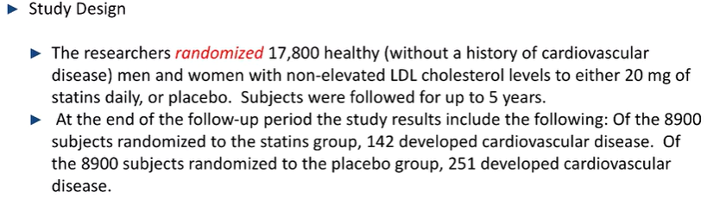

**Results**

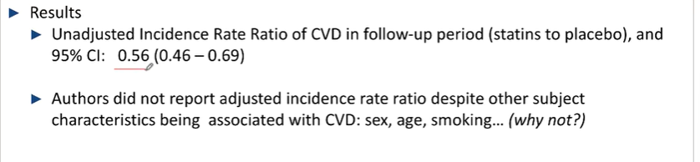

* From the study, it has been shown that taking 20mg of Statin a day had a 44% lower risk of developing cardiovascular disease as compared to individuals who took a placebo, over 5 years
* Adjusted incidence rate ratios were not reported (sex, age, smoking) etc. were not reported as the study was randomised and thus there should be an approximately equal composition of individuals in both the statin and placebo group, thus there should be no risk of confounding

**Investigating interactions between characteristics and statins**

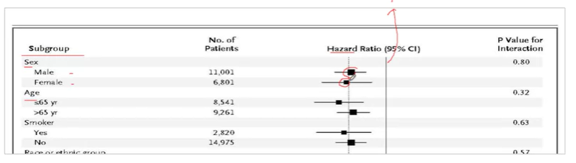

-as the confidence intervals for the different characteristics were all statistically significant and all-overlapped, they found that there was no large difference in the effects of statins on different groups due to overlaps in confidence intervals. Thus, there is no need to modify treatment for different groups.

## Confounding V Effect Modification

-Confounding is a possibility in non-randomised studies

-Confounding results in a distorted estimate (increased or decreased) of the Y/X relationship via the crude association

-Effect Modification is a possibility regardless of the study design

-Effect modification for Y and X can occur if a third factor Z is related to the association btwn Y and X

Assessing Confounding:

* An adjusted Y/X association can be estimated, adjusted for a measured potential confounder(s) by comparing the separate Y/X modifications (and 95% CIs) across the values of a potential effect modifier

Confounding – study designs:

* The potential for confounding can be minimized by designing a randomised study
* Much research can only be done observationally. Thus, confounding is a possibility
* Potential confounders of **key relationships should be conceptualized before the start of the study, and must be measured as part of the study**

Effect Modification: Study Design Considerations:  
- Can occur in both randomised and observational study designs

* However, it is best to have a sense of any potential effect modifications of interest prior to designing a study
* This limits the number of investigations once the data is collected
* Allow for the study design to be powered to detect an effect modification of interest with a certain power